**How to make Android Image work on Hyper V with Azure Labs**

**Step 1) Create the Android Image in Hyper V**

The process for this is the same as the process you used to create Ubuntu Image. The one change being instead of picking the Ubuntu labelled HDD, you pick the Android Labelled one.

**Step 2) Boot into ‘recovery mode’**

Assuming you did the last step correct, your Android image will boot but end up at a command prompt. It will look very familiar to people who have used linux before.  
To make the GUI work we need to change the grub config file.

Reboot the Android VM, and keep pressing the escape key. Make sure that your mouse is ‘captured’ by the Android VM so the escape command is being sent to the VM. If you have done this correctly, you should come to a grub boot menu.

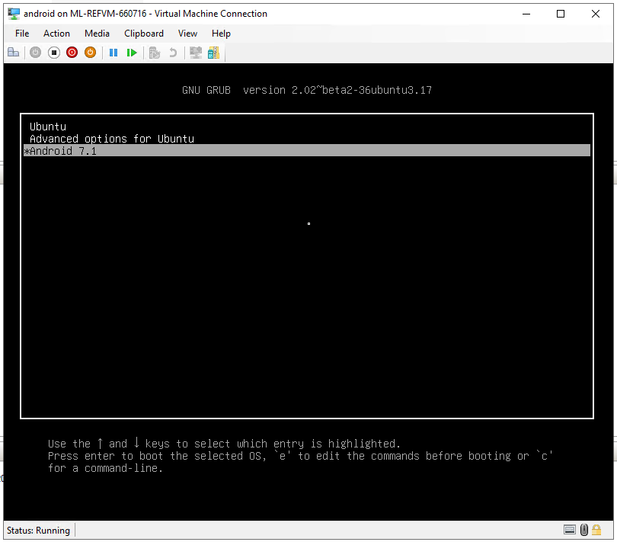

At this point choose “Advanced options for Ubuntu”, and then select the “(recovery mode)” option.  
Select “resume”, when asked to confirm press “<OK>”. Login is “root”, pw is “root”

**Step 3) Edit grub.cfg**

In the command prompt type “nano /boot/grub/grub.cfg”

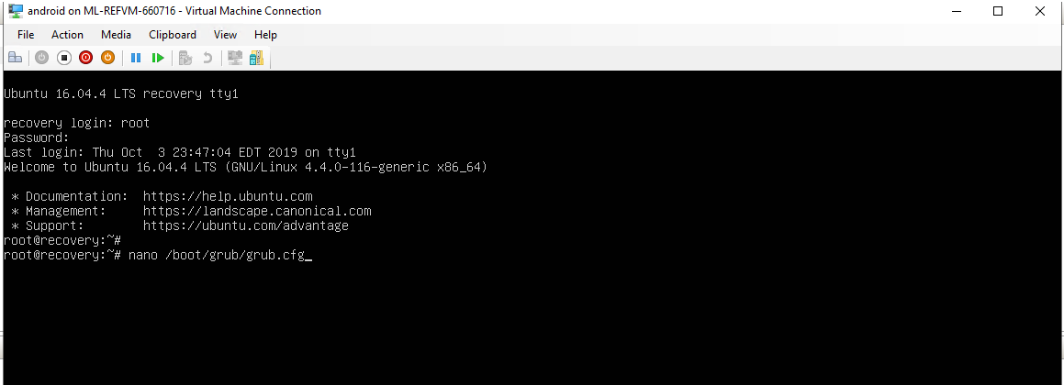

Goto the line 206. To do this Hold “Ctrl + _”

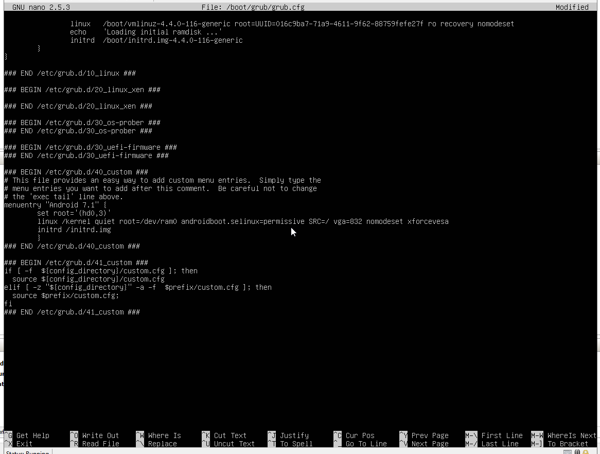

Add “vga=832 nomodeset xforcevesa” to the end of line 206, so it looks like the above picture.  
Press “Ctrl+X” to exit, when it asks if you want to save press “Y”, keep the same file name (press enter)

When you are at the command prompt type “reboot”

Congratulations! You should now boot into an Android GUI